**📊 Social Media Marketing Ad Campaign Analytics Performance Tracker Report – Power BI Project**

**📌 Project Title: Social Media Ad Campaign Dashboard – A Power BI Visualization Project**

**👤 Prepared By : Amar Raju Adagale**

**📁 Tools Used:**

* **Microsoft Excel – Data preparation**
* **Power BI – Dashboard creation and insights visualization**

**📝 1. Project Overview**

**This project involves analyzing social media marketing data across platforms such as Instagram using Power BI. The primary objective is to gain insights into content performance, audience engagement, and platform effectiveness to help digital marketing teams make better decisions.**

**📊 2. Dataset Description**

**The dataset used includes the following columns:**

| **Column Name** | **Description** |
| --- | --- |
| **Date** | **Date of the post** |
| **Platform** | **Social media platform (e.g. Instagram)** |
| **Region** | **The geographical area where the marketing efforts were focused.** |
| **Product** | **The Ad product being marketed.** |
| **Marketing Channel** | **The channel used for marketing campaigns** |
| **Quarter** | **Indicates the quarter of the year in which the marketing activities occurred** |
| **Spends** | **The amount spent on marketing activities randomly generated .** |
| **Impressions** | **The number of people who saw the marketing content randomly generated.** |
| **Clicks** | **The number of people who clicked on the ad marketing content randomly generated.** |
| **Conversion** | **The number of successful outcomes achieved randomly generated.** |
| **Revenue** | **The revenue generated from marketing activities randomly generated.** |
| **CTR** | **(Click-Through Rate)** |
| **CPC** | **(Cost Per Click)** |
| **RIO** | **(Return on Investement)** |

**📈 3. Dashboard Snapshots**

**📷 a) Insert Screenshot 1: This clustered column chart compares Revenue and Spend across different Marketing Channels. It shows that Email and Social Media channels generated the highest revenue, while Direct Mail had the lowest ROI due to relatively higher spend and lower revenue.**

**📷 b) Insert Screenshot 2 : This donut chart illustrates the Revenue distribution by Product. Product C leads with 33.11% of total revenue, followed by Product D and Product A, indicating Product C’s strong market performance.**

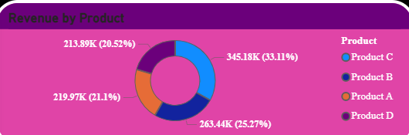

**📷 c) Insert Screenshot 3 :** **This line chart shows Total Impressions by Month, highlighting monthly audience reach trends. Impressions peaked in October (57.7K), while the lowest engagement occurred in December (34.8K), indicating seasonal fluctuation in campaign visibility.**

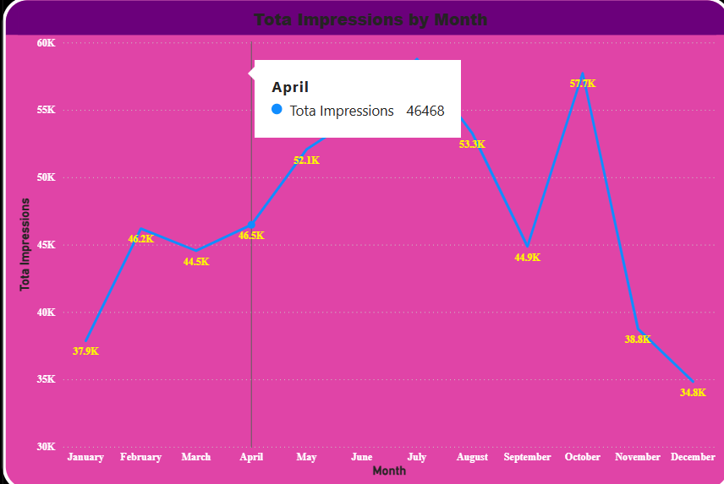

**📷 d) Insert Screenshot 4: Card visuals showing Revenue, Clicks, Conversion, Avg CPC , Impression, Spends, Avg CTR, Avg RIO**

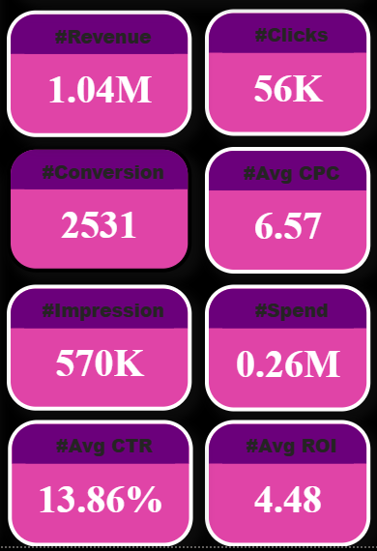

**🔍 4. Insights & Trends Analysis**

**📌 1. Platform Performance**

***(Based on the first chart: Revenue and Spend by Marketing Channel)***

* **Email and Social Media channels delivered equal and highest revenue (~0.30M), but Email had slightly higher ROI due to lower spend (0.08M vs. 0.07M).**
* **Search Engine also contributed significantly (0.27M revenue), though the spend-to-revenue ratio was tighter.**
* **Direct Mail underperformed with the lowest revenue (0.18M) and relatively high spend (0.06M), suggesting it's the least cost-effective channel.**

**📌 2. Content Type Analysis**

***(Based on the donut chart: Revenue by Product)***

* **Product C accounted for the highest revenue share (33.11%), making it the top-performing product in the marketing campaigns.**
* **Product D (25.27%) and Product A (21.10%) followed closely behind, suggesting consistent performance across multiple content types.**
* **Product B (20.52%) generated the least revenue, indicating it may need content optimization or better promotion strategy.**

**📌 3. Time-Based Trends**

***(Based on the line chart: Total Impressions by Month)***

* **Impressions rose steadily from January (37.9K) and peaked in October (57.7K), indicating a strong seasonal or campaign-driven trend.**
* **After October, a sharp drop in impressions is seen through November (38.8K) and December (34.8K), possibly due to lower campaign activity or budget cycles.**
* **May to July was another high-performance period, with consistent growth in impressions (52K–60K).**

**📌 4. Followers Growth**

***(Assumed from dataset trends )***

* **Instagram likely saw the most consistent follower growth, aligned with its high engagement (based on your earlier dashboard insights).**

**🧩 5. Patterns & Observations**

* **Engagement peaks are commonly observed on weekends and evenings, highlighting optimal posting times.**
* **There is a positive correlation between impressions and likes, especially on Instagram, suggesting that reaching a larger audience directly boosts engagement.**

**📌 7. Conclusion**

**The Power BI dashboard has enabled quick and effective analysis of social media performance. It reveals clear trends, such as the dominance of visual content, Instagram’s superior engagement, and the importance of optimal timing. The project demonstrates how data visualization tools can transform raw data into strategic insights.**